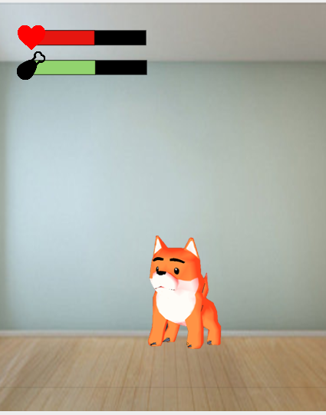 The main screen of D&J Game. The background will be changed in the future.

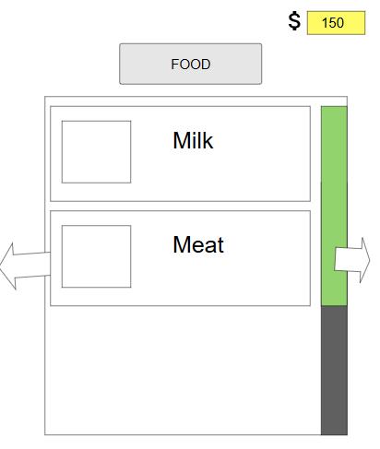

* This is the shop UI prototype which contains milk, meat and more which will be further expanded.